Data Migration for SQL SERVER DB to Cosmos DB
A step-by-step guide to help migrate your data from SQL Server to Cosmos DB using Azure Data Factory (ADF). Follow these steps carefully to set up and execute your migration process.

Step 1: Set Up Your Azure Data Factory Environment
- Create an ADF Instance (if not already available):
  - Log in to the Azure Portal.
  - Click or search for “Data Factory”.
  - 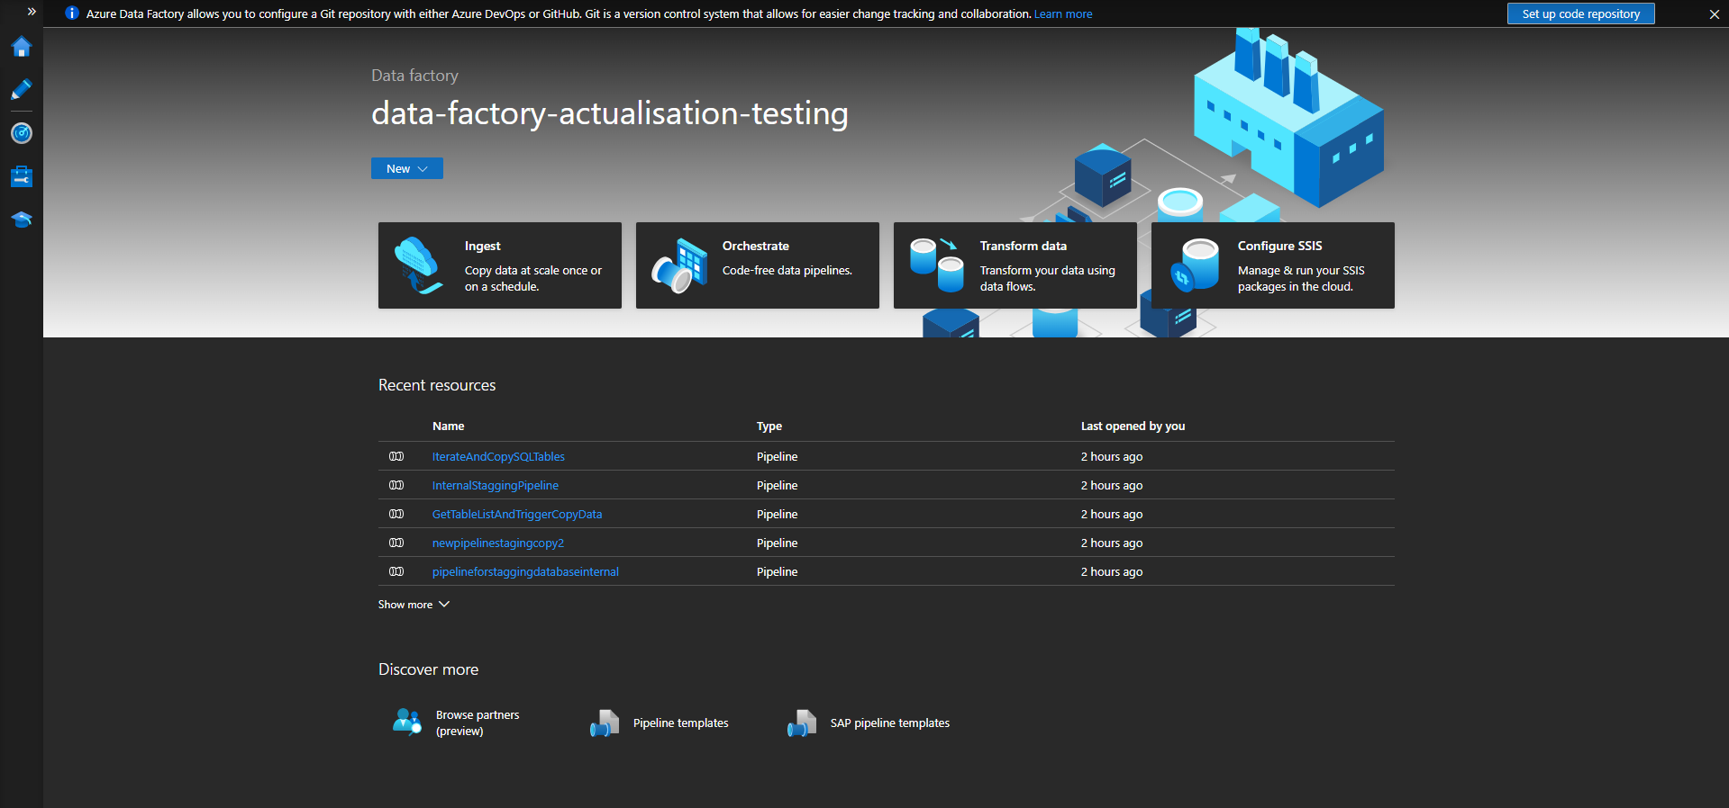
  - Click “Create”, fill in the required details (subscription, resource group, region, and instance name), and click “Review + create”.
  - Once validated, click “Create” to deploy your instance.
- Launch the ADF Studio:
  - After deployment, navigate to your Data Factory instance.
  - Click on “Author & Monitor” to open the ADF Studio where you will design and manage your pipelines.
  - 

Step 2: Create Linked Services
Linked services in ADF define the connection information for your data sources and sinks.

2.1. Create a Linked Service for SQL Server
- In ADF Studio, click on the “Manage” tab (gear icon on the left).
- Under “Connections”, click “Linked services”.
  - 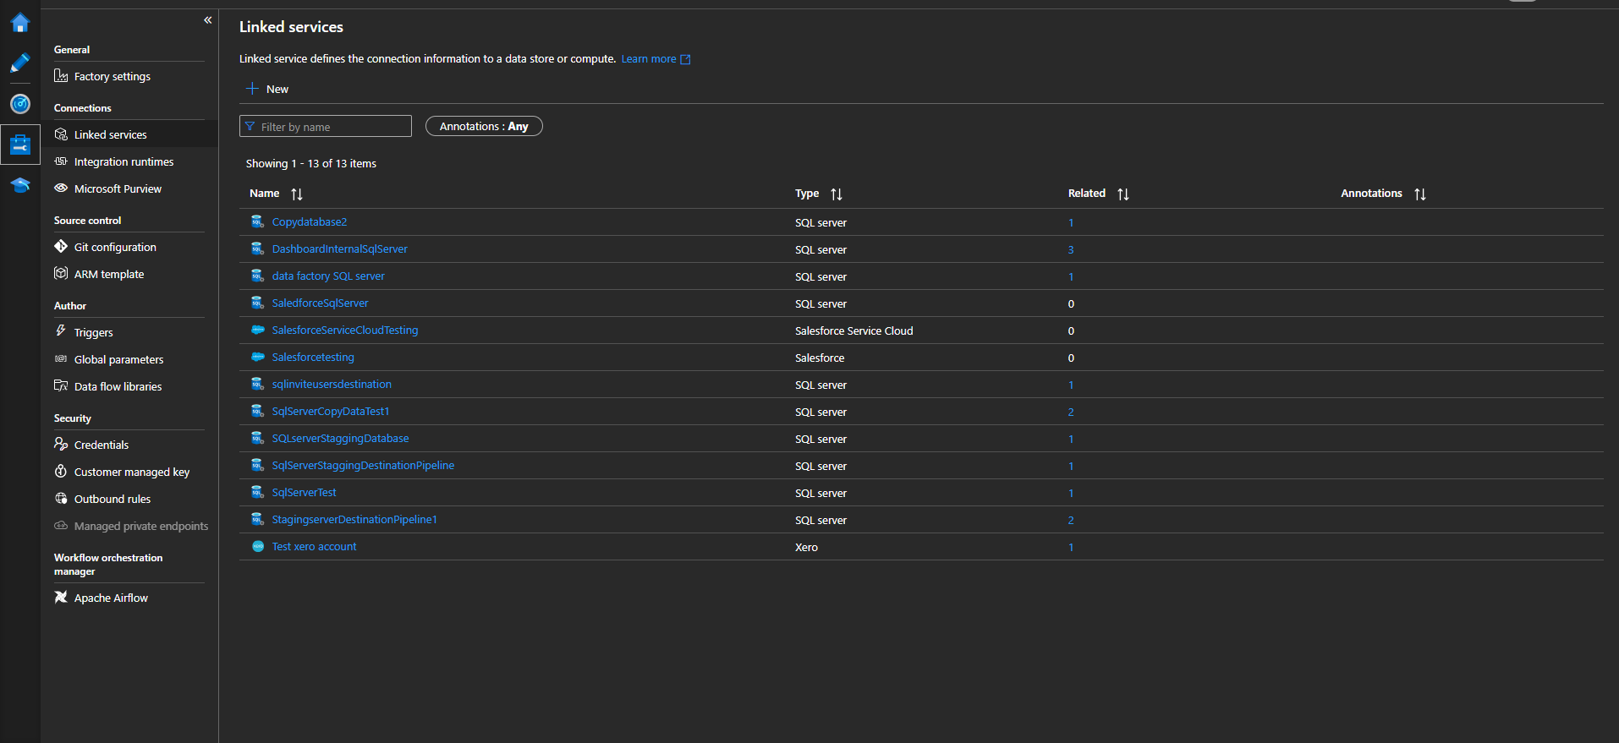
- Click “+ New” and select “SQL Server” (or “Azure SQL Database” if applicable).
- In the connection configuration pane:
  - Name: Provide a descriptive name.
  - Server name: Enter the SQL Server’s hostname.
  - Database name: Enter the target database name.
  - Authentication: Choose the appropriate method (SQL Authentication or Windows Authentication) and enter credentials.
  - Optionally, adjust any advanced settings.
- Click “Test connection” to ensure connectivity, then click “Create”.

2.2. Create a Linked Service for Cosmos DB
- Again, in the “Linked services” section, click “+ New”.
- 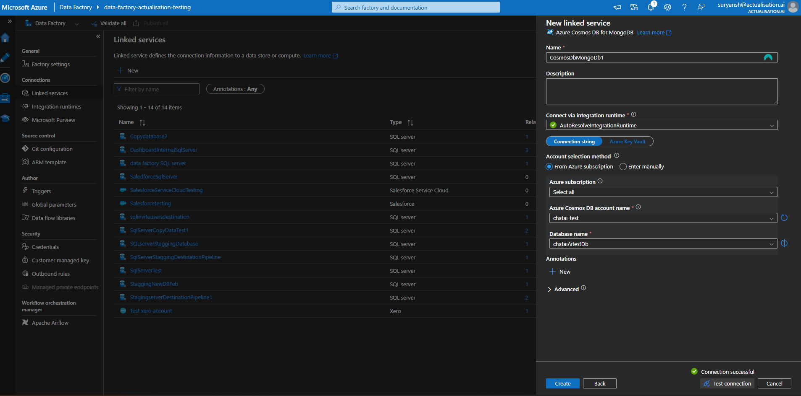
- Search for and select “Azure Cosmos DB for NoSQL” (or the API type you intend to use, such as SQL API).
- Configure the linked service:
  - Name: Provide a descriptive name.
  - Account Endpoint: Enter your Cosmos DB account URI.
  - Account Key: Enter the primary (or secondary) key from your Cosmos DB account.
  - Database Name: Specify the target database in Cosmos DB.
- Click “Test connection” to verify connectivity, then click “Create”.

Step 3: Create Datasets
Datasets define the structure and location of your data.

3.1. Create a SQL Server Dataset (Source)
- In ADF Studio, switch to the “Author” tab.
- Under the “Datasets” section, click “+ New Dataset”.
  - 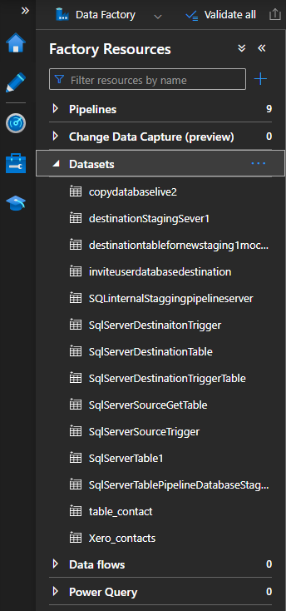
- Select “SQL Server” (or “Azure SQL Database”).
- Configure the dataset:
  - Name: Provide a name.
  - Linked Service: Choose the linked service you created for SQL Server.
  - Table: Select the table you wish to migrate or choose to write a query by selecting the option “Table or query” and entering your SQL query.
- Click “ok” to create the dataset.

3.2. Create a Cosmos DB Dataset (Sink)
- Under “Datasets”, click “+ New Dataset”.
- Select “Azure Cosmos DB for NoSQL”.
- Configure the dataset:
  - Name: Provide a name.
  - Linked Service: Select your Cosmos DB linked service.
  - Collection/Container Name: Enter the name of the container (you may need to create this container first via the Azure Portal if it doesn’t exist).
  - Partition Key: Specify the partition key (this is crucial for Cosmos DB performance and scaling).
- Click “publish” to finalize the dataset creation.

Step 4: Create and Configure the Pipeline
- In the “Author” tab, click “+ New Pipeline”.
- Give your pipeline a meaningful name.

4.1. Add a Data flow
- In the pipeline canvas, drag the “Data Flow” activity.

4.2. Configure the Source
- In the “Source” tab of the activity:
  - Source Dataset: Select multiple sources.

4.3. Configure the Data flow
- In the “Source” tab:
  - Source Dataset: Select DB.

4.4. Add JOINS for multiple sources
- 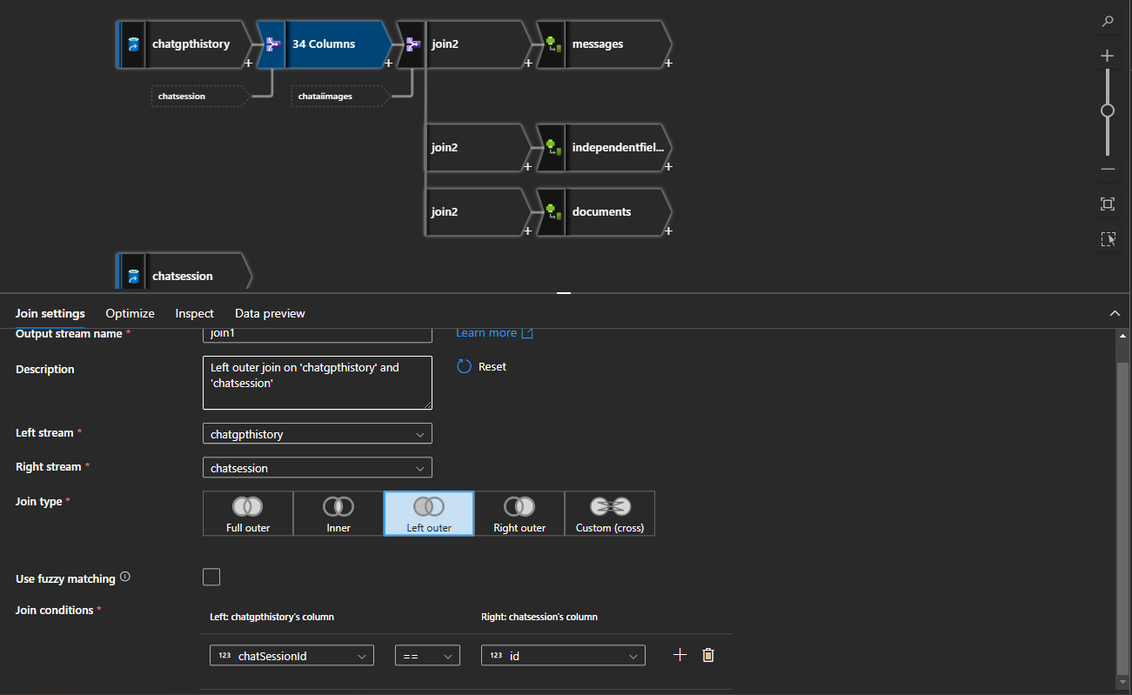
- 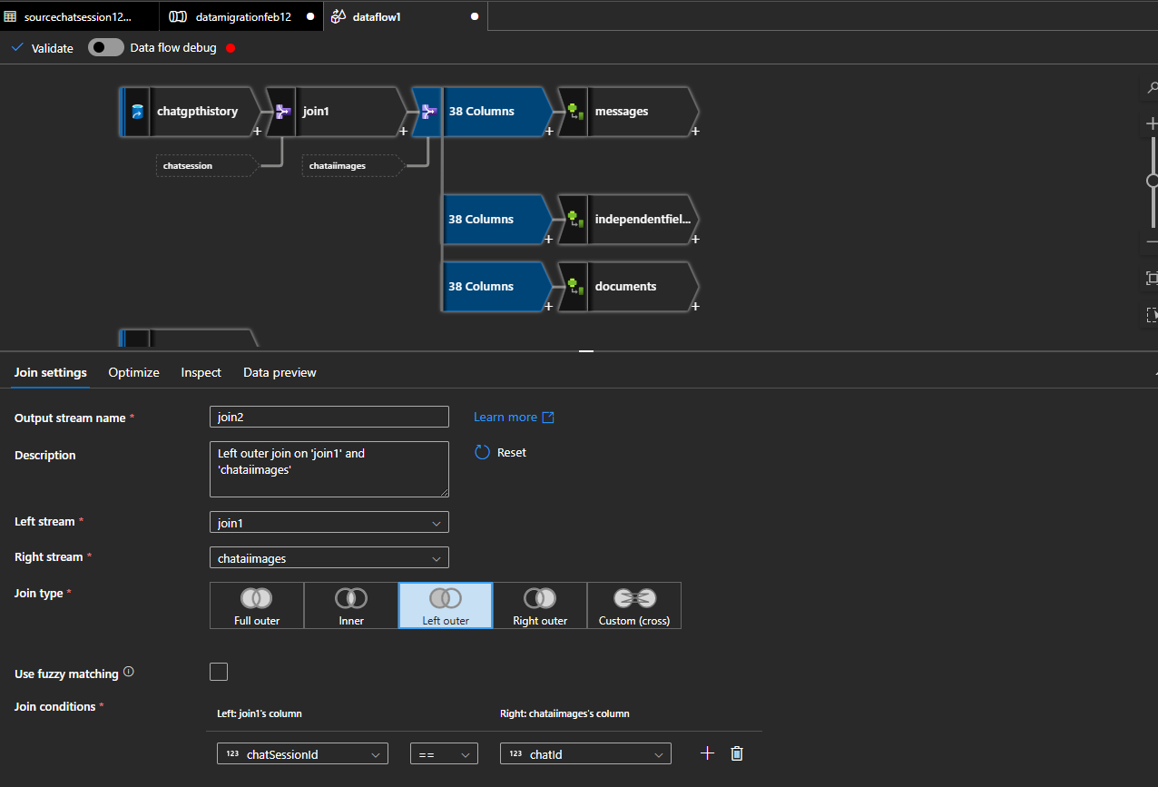
- Validate and map:
  - Validate and map the columns by entering expressions.

4.5. Derived Column and Aggregate for JOIN2
- 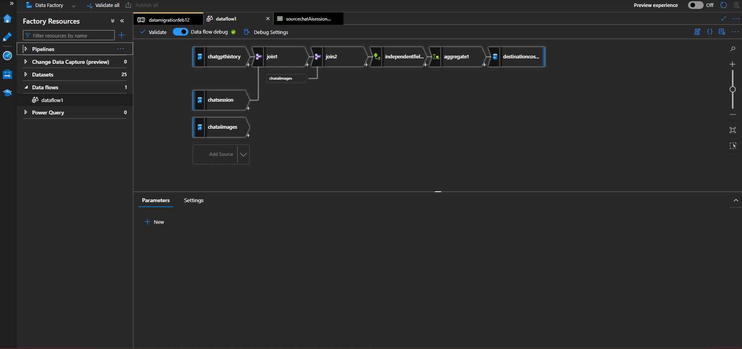
- Map the columns with the required JSON schema.

Step 5: Validate and map

5.1. Debug the Pipeline:
  - Click the “Debug” button in the pipeline canvas. This will run the pipeline in test mode.
  - Monitor the progress and check the output logs for any errors.
  - Validate that the sample data appears correctly in Cosmos DB by checking your Cosmos DB container via the Azure Portal.

5.2. Review Mappings and Data:
  - If you see any discrepancies in data, adjust the field mappings or transformation settings in your pipeline and debug again.

Step 6: Validation Step

6.1. Data Validation from your data preview:
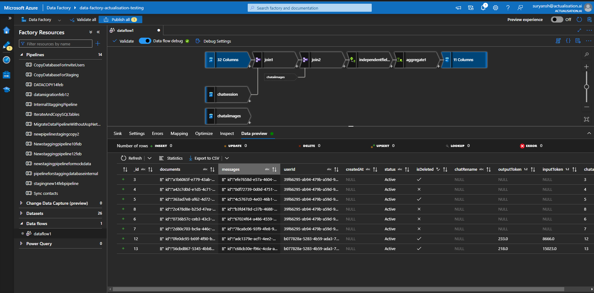

Step 7: Final Steps
- Clean the data with Python script if necessary.
- If RU is around 400 use batching with Python script.
- Validate the result through JSON viewer.
- Destination:
  - 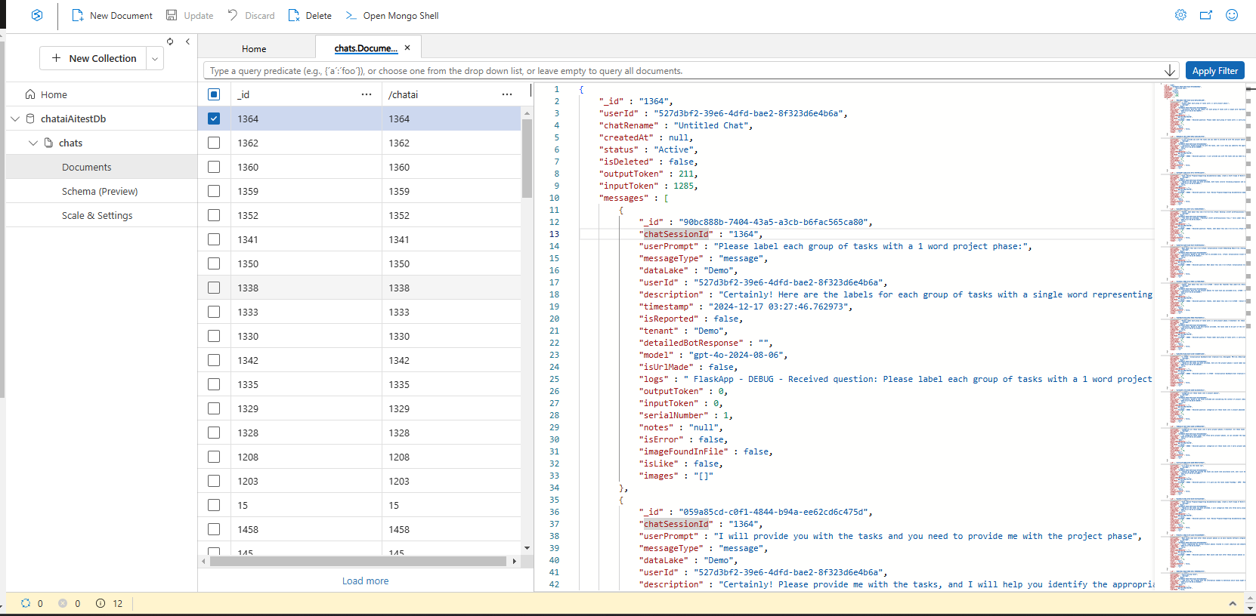
  - Validate the schema with the result.

Alternate:
- You can copy data from Azure data factory.
  - 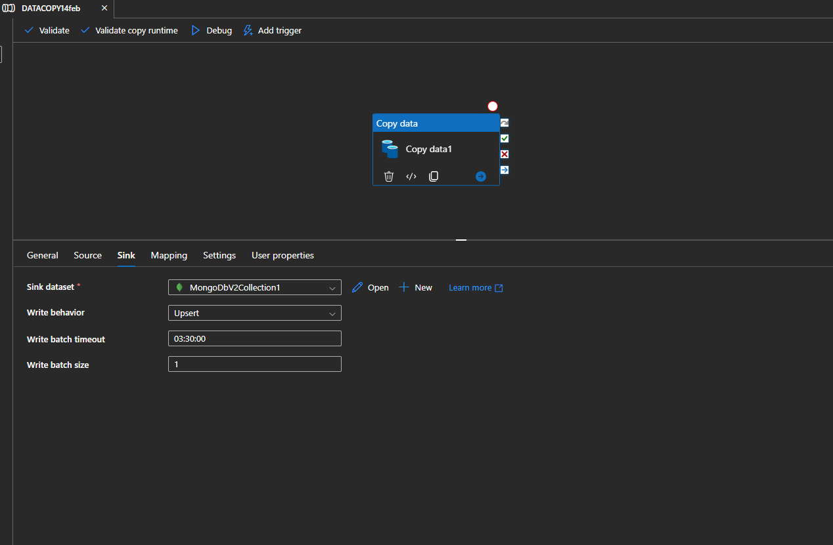
- But it will store JSON data as string-based.
- It will pick the data type automatically.
- It’s not dynamic. So you cannot alter or perform a batch process even if you try with 400 RU but in python script, you can continue the process even if it will throw an error.

